**CHAPTER-1**

**Introduction**

This chapter discusses the origin of the problem, the problem description, basic definitions, and applications.

**1.1 Origin of the Problem:**

It is common for patients to face difficulties in finding a suitable doctor for their medical needs, and traditional healthcare systems may involve long waiting times and limited access to medical care. The origin of this project will be to address these issues and provide an efficient and convenient way for patients to access medical care online or offline, while also improving the overall patient experience.

The lack of a centralized system for managing patient care. Currently, there are multiple systems in place for different aspects of patient care, such as booking appointments, managing lab tests, and prescribing medications. This leads to a fragmented experience for patients and makes it difficult for healthcare providers to share information and collaborate on patient care. For example, patients may have to book appointments through one system, manage their lab tests through another system, and get their medications from yet another system. This can be confusing and time-consuming for patients, and it can also lead to errors and delays in care.

Healthcare providers also face challenges due to the lack of a centralized system. For example, doctors may have to access multiple systems to get a complete picture of a patient's health history, and they may have to manually enter information into multiple systems, which can be time-consuming and error-prone.

A centralized system for managing patient care would address these challenges by providing a single platform for all aspects of patient care such as booking slots for the consultation by selecting a profile from the existing applications, then user can select a doctor based on symptoms or specialist of choice , after slot time selection and payment, consultation gets confirmed and after the consultation patient can book medicines and lab tests online .This will make it easier for patients to manage their care, and it would make it easier for healthcare providers and patients to share information and collaborate on patient care. These features could further improve the quality of patient care.

**1.2 Basic definitions and Background:**

**REACT JS:**

React.js plays a pivotal role in shaping the user interface (UI) of a web application featuring intricate healthcare functionalities like booking consultations, ordering lab tests, purchasing medicines online, and selecting doctors based on symptoms or specializations, with consultation options spanning audio, video, or text. Employing a component-based architecture, React.js facilitates the creation of modular UI components for each distinct feature, ensuring code modularity and reusability. This approach streamlines development, making it easier to manage complex interactions within the application.

The dynamic user interfaces delivered by React.js are instrumental in providing a responsive and seamless experience for users engaging in healthcare-related tasks, such as filling out consultation forms or reviewing lab results. The library's virtual DOM optimizes updates, enhancing performance and contributing to a smoother user experience. For features involving real-time communication, React.js seamlessly integrates with technologies supporting audio, video, and text consultations, offering flexibility and versatility in user interaction.

React.js excels in state management, efficiently handling the dynamic data associated with healthcare applications. This is vital for functionalities like real-time doctor availability updates or tracking the progress of lab test orders. Additionally, the library easily integrates with backend services and APIs, enabling the web application to communicate with servers for tasks like appointment booking and processing online medicine orders. This backend integration ensures the seamless flow of data, supporting the accuracy and timeliness of information presented to users.

**NEXT JS :**

Next.js plays a crucial role in crafting the user interface (UI) of a web application featuring intricate healthcare functionalities like booking consultations, lab tests, online medicine orders, and doctor selection based on symptoms or specializations, with consultation options spanning audio, video, or text. Leveraging Next.js, a React framework, facilitates server-side rendering and provides a robust foundation for building dynamic and responsive UIs. The framework's file-based routing simplifies the organization of pages and components, contributing to a more modular and scalable codebase.

One of Next.js' significant advantages is its ability to optimize performance through server-side rendering, ensuring faster page loads and improved user experiences. This is particularly crucial in healthcare applications where users engage in complex interactions, such as scheduling consultations or reviewing medical information. Next.js also supports static site generation, allowing for the pre-rendering of pages at build time, which is advantageous for content that doesn't frequently change, such as general information about consultations or lab tests.

The dynamic routing capabilities of Next.js are beneficial for features like selecting doctors based on symptoms or specializations. It enables the creation of dynamic pages that adapt to user input, providing a personalized and interactive experience. Additionally, Next.js seamlessly integrates with APIs and backend services, facilitating the communication necessary for functionalities like booking appointments or processing online medicine orders. This ensures the consistency and accuracy of information presented to users.

For features involving real-time communication, such as audio or video consultations, Next.js can integrate with third-party libraries or services designed for these functionalities. This ensures a seamless and responsive experience during consultations, meeting the diverse needs of users who may prefer different communication modes.

**MONGO DB:**

MongoDB is employed in creating schemas for the database in the context of healthcare applications developed using React Native for mobile and React.js for web. The flexible and schema-less nature of MongoDB, a NoSQL database, is particularly advantageous in modeling the diverse and evolving data structures associated with features like booking consultations, lab tests, online medicine ordering, and selecting doctors based on symptoms or specializations. MongoDB's ability to handle nested and complex data structures allows for the storage of information such as patient details, appointment schedules, lab test results, and doctor profiles in a way that aligns with the dynamic requirements of healthcare applications.

The connection between MongoDB and the frontend applications is established through the use of drivers or libraries that facilitate interaction with the database. In the case of React Native and React.js, libraries like Mongoose for Node.js or the official MongoDB driver for JavaScript can be utilized. These libraries provide an interface for the frontend applications to perform operations such as querying, inserting, updating, and deleting data in the MongoDB database.

In the context of a healthcare application's frontend, MongoDB is accessed through API endpoints. These endpoints are created on the backend, which could be developed using Node.js, Express.js, or another server-side technology. The frontend applications, developed using React Native and React.js, make HTTP requests to these API endpoints to retrieve or manipulate data in the MongoDB database. For example, when a user books a consultation or orders medicine, the frontend sends a request to the backend, which in turn interacts with MongoDB to store or retrieve the relevant data.

The integration of MongoDB with the frontend applications is crucial for maintaining the consistency of information displayed to users across platforms. The dynamic nature of healthcare data, which includes appointment schedules, doctor availability, and patient records, is effectively managed in MongoDB, ensuring that the frontend applications can retrieve and display up-to-date information to users. The use of MongoDB in this context allows for scalability and adaptability, accommodating the evolving requirements of healthcare applications that feature diverse functionalities, including audio, video, or text consultations. In summary, MongoDB serves as a robust and flexible backend database solution, seamlessly connecting with React Native and React.js frontend applications to provide a reliable foundation for healthcare features such as booking consultations, lab tests, and online medicine ordering.

**REACT NATIVE :**

React Native serves as an integral tool in crafting the user interface (UI) for a mobile application with diverse healthcare features, including booking consultations, lab tests, and online medicine services, as well as the ability to select doctors based on symptoms or specializations with consultation options ranging from audio and video to text. At the heart of React Native's efficacy is its component-based architecture, allowing developers to create modular and reusable UI components that correspond to distinct functionalities within the application. Each feature, such as consultation booking or medicine ordering, is encapsulated in a component, fostering code reusability, scalability, and maintainability.

The framework's capability to deliver a responsive and dynamic user interface is crucial for healthcare applications where users engage in complex interactions, such as submitting consultation requests or reviewing lab results. React Native achieves this through its virtual DOM, optimizing updates for better performance and ensuring a smooth user experience. For functionalities like audio or video consultations, React Native seamlessly integrates with third-party libraries, facilitating the inclusion of real-time communication features. This integration enables users to consult with healthcare professionals using their preferred mode—audio, video, or text—enhancing the versatility of the application.

React Native's state management mechanisms play a pivotal role in handling the dynamic nature of healthcare data. Managing states efficiently allows for real-time updates on doctor availability or tracking the status of lab test orders. Additionally, the framework facilitates the integration of backend services and APIs, enabling the mobile application to interact with servers for tasks such as booking appointments or processing online medicine orders. This backend integration is crucial for maintaining the seamless flow of data and ensuring the accuracy of information presented to users.

**1.3 Problem Statement:**

The project aims to develop a comprehensive healthcare management system through the development of a Web application and a Mobile Application. The system will streamline and improve the healthcare experience for users by providing various features such as appointment scheduling by selecting a doctor based on symptoms or specialists of users choice and after the successful completion of appointment doctor generates prescription that includes list of medicines and lab test, patients can use laboratory module and pharmacy module for booking medicines and lab tests.

The goal is to enhance the efficiency of healthcare delivery and make it more accessible and convenient for patients.

**1.4 Applications:**

A healthcare management system can have a wide range of applications across different healthcare settings, including hospitals, clinics, private practices, and nursing homes. Here are some of the potential applications of a healthcare management system:

Patient management: A healthcare management system can be used to manage patient records, including medical history, demographics, test results, and medications. It can also be used to schedule appointments, track patient visits, and manage billing and insurance information.

Electronic health records (EHRs): An EHR system can be integrated with a healthcare management system to provide a comprehensive view of a patient's health history. This can help healthcare providers make more informed decisions about diagnosis, treatment, and medication management.

Telemedicine: With the rise of telemedicine, a healthcare management system can be used to facilitate remote consultations between healthcare providers and patients. This can be especially useful for patients in rural areas or those who have difficulty traveling to appointments.

Inventory management: A healthcare management system can be used to manage inventory of medical supplies and equipment, ensuring that there is always adequate stock on hand and minimizing waste.

Analytics and reporting: A healthcare management system can provide valuable insights into patient care and operational performance. It can be used to generate reports on patient outcomes, quality measures, and financial performance, helping healthcare providers identify areas for improvement.

**CHAPTER-2**

**Review of Literature**

**2.1 LITERATURE REVIEW:**

The purpose of this literature review is to explore the current state of the art in healthcare management systems and identify the key challenges and opportunities facing the industry.

**2.2 SUMMARY OF LITERATURE STUDY:**

In recent years, there has been a growing interest in the use of data and analytics to improve healthcare management. Healthcare organizations are increasingly collecting and analyzing data from a variety of sources, such as electronic health records, claims data, and patient surveys. This data can be used to improve decision-making in areas such as resource allocation, clinical care, and patient satisfaction.

Some of the key trends in healthcare management research include:

The shift to value-based care: This is a shift away from paying for the volume of healthcare services provided to paying for the quality and outcomes of care. This is leading to a greater focus on preventive care, population health, and patient-centered care.

The rise of big data and analytics: Healthcare organizations are increasingly using data and analytics to improve decision-making in all areas of the organization.

The growing importance of patient engagement: Patients are becoming more involved in their own healthcare, and healthcare organizations are increasingly recognizing the importance of engaging patients in their care. The need for interprofessional collaboration: Healthcare is becoming increasingly complex, and there is a growing need for healthcare professionals to collaborate with each other to provide the best possible care to patients.

**FOR WEB APPLICATION:**

Table.2.1: Comparison of Web applications

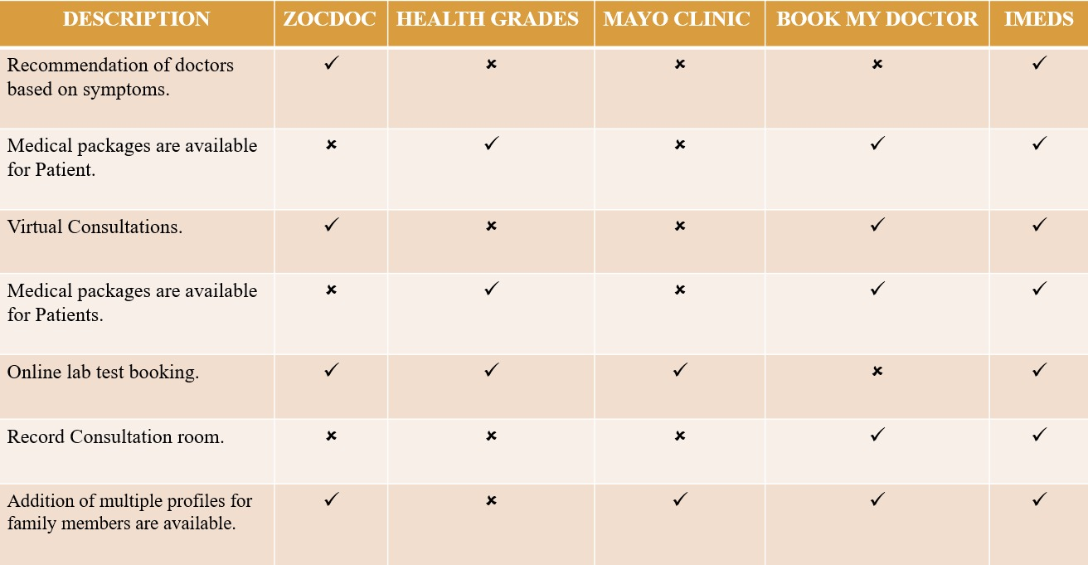

These are the features of the health care applications that were in use till date. In order to build a efficient health care application, we will be including additional features in our application such as booking appointments online by selecting doctors based on selected symptom or specialist of their choice. Booking appointment for themselves or any other relations. Mode of appointment can be customized according to user choice like text, audio and video. Consultation recording can be done. Health check up packages can be included for appointments. Insurance claim assistance is also available. Doctor profiles can be clearly reviewed for ratings before booking an appointment. Notifications and remainders are available and can be customized. Rescheduling and cancellation of appointments are available. Book medicines and lab tests online. And the whole application is also available for mobile interface.

**FOR MOBILE APPLICATION:**

Table.2.2.1: Comparison of Mobile applications1

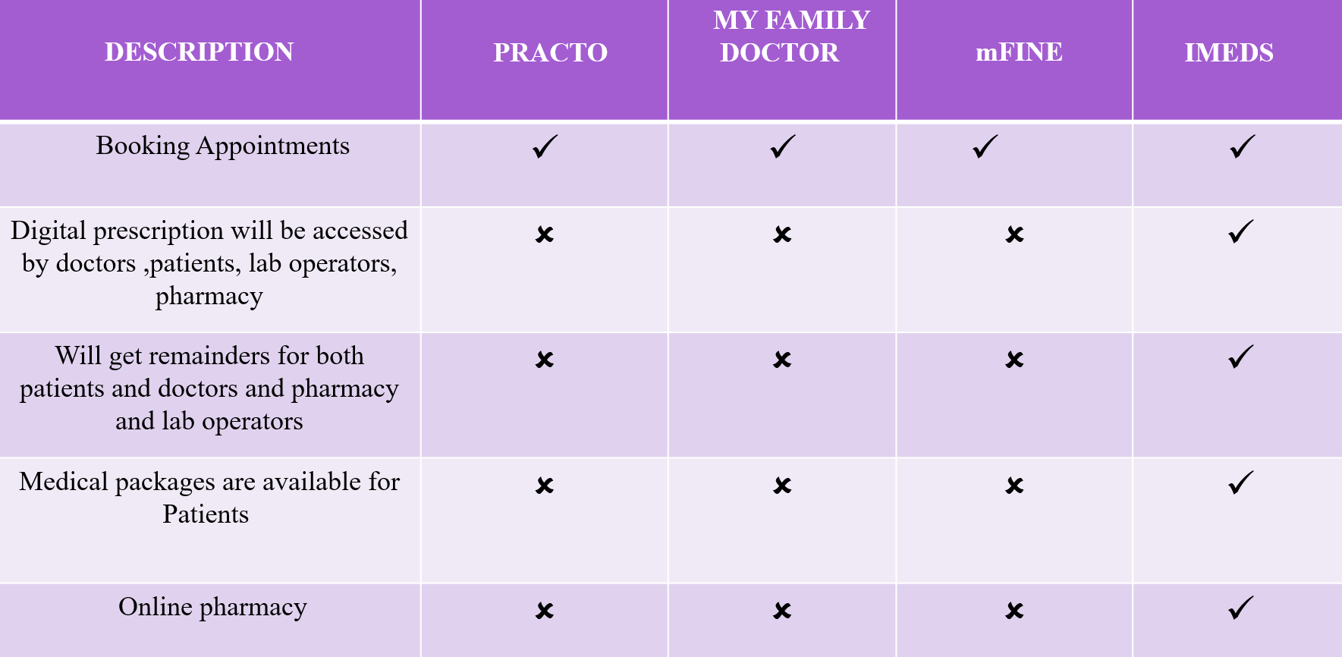

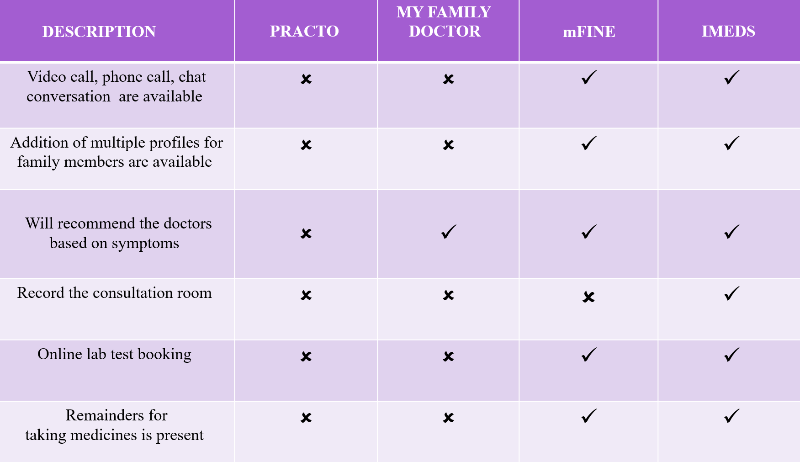 Table.2.2.2: Comparison of Mobile applications2

**PRACTO APP**

* The Practo app [1] is a digital health platform designed to help patients with colorectal diseases.
* A search of the literature found limited research specifically related to the Practo app.
* However, there are studies on similar digital health platforms that provide insight into the potential benefits of such apps.
* For example, a study by Lai et al. (2020) found that a mobile health platform for patients with inflammatory bowel disease (IBD) led to improvements in disease management and patient satisfaction.
* Another study by Faleiro et al. (2020) found that a digital health platform for patients with chronic gastrointestinal disorders improved patient engagement and symptom monitoring.
* These findings suggest that the Practo app may also be beneficial for patients with colorectal diseases.

**MY FAMILY DOCTOR APP:**

* The My Family Doctor app is a telemedicine platform that allows patients to connect with doctors remotely.
* There is a growing body of research on telemedicine, which provides insights into the potential benefits and limitations of such platforms.
* For example, a systematic review by Flodgren et al. (2015) found that telemedicine can lead to improvements in patient outcomes, such as reduced hospital admissions and improved clinical parameters. Another study by Whitten et al. (2018) found that telemedicine can improve patient satisfaction and reduce healthcare costs.
* However, there are also limitations to telemedicine, such as concerns about patient privacy and the potential for misdiagnosis.
* Overall, the literature suggests that the My Family Doctor app has the potential to improve access to healthcare and patient outcomes, but further research is needed to fully evaluate its effectiveness and safety.

**mfine APP:**

* mfine's[3] online doctor consultation service allows you to connect with top-rated doctors from over 30 specialities, including general medicine, pediatrics, gynecology, dermatology, and more.
* Consultations can be done via chat, audio, or video call, and typically last for 15-20 minutes.
* mfine also offers a variety of health packages that include multiple doctor consultations and lab tests at a discounted price.
* In addition to online doctor consultations, mfine also offers a wide range of lab tests and health checks at home.
* mfine partners with NABL-accredited labs to offer over 1000 different tests and check-ups. The patients can book a test or check-up at your preferred time and date, and a lab technician will come to patient’s home to collect the samples.
* Reports will be uploaded to the app within 24-48 hours.
* mfine also offers a convenient way to order medicines online.
* Patients can simply upload the prescription to the app or select the medicines you need from the mfine pharmacy.
* mfine offers discounts on medicines and prescription refills, and delivers the medicines to the doorstep within 24-48 hours.

**CHAPTER-3**

**Proposed Method**

**3.1 DESIGN METHODOLOGY**

The Healthcare Management system is a group of two applications, Web application and mobile application. The web application will be installed on could and mobile application will be installed on smart phones with touch screen. The web application shall be able to process at least 100 requests per second. The web application shall not consume more than 40% of memory. The mobile application shall be supported on Android and iOS devices.

**3.1.1 PRODUCT FUNCTIONS**

The Healthcare Management System shall have following modules:

• Web application

• Mobile application

• Backend for the application

**Web application:**

The web application is the main application and shall provide APIs to be consumed by mobile applications. The web application shall also provide all features of mobile application to be accessed in any browser in a laptop or a computer. The web application shall be developed in Model View Controller architecture wherein there is a clear separation in presentation layer, business layer and data layer. The application shall be scalable to add more features in future based on requirement.

**Mobile Application:**

The Mobile application shall be available in Google play store or Apple store for downloading and installation. The app shall differentiate users based on login credentials (registered phone number). Same app shall be used by doctors, patients and lab operators. The app shall be user friendly, easy to navigate and supported on varied screen sizes. The app shall consume APIs provided by Web application. The app shall support multiple users (family members) under one registered phone number and email Id.

**Backend for the application:**

Database shall be used for storing user data, transactional data, reports and case studies. The data stored in database shall be used for report generation.

***3.1.2 User Characteristics***

There are five types of users differentiated based on registered mobile number.

Doctor: The doctor user shall have access to appointment list, calendar, prescriptions and lab reports etc

User: User shall have access to schedule of appointments, scheduling lab tests, online consultations, consultation room, prescriptions, lab reports, reminders etc.

Lab admin: Lab admin shall have very limited access to appointments, uploading lab reports only.

Pharmacy Operator: Pharmacy operator shall be able to generate bills, add stock, update stock etc.

System User: The system user shall have complete access to all modules and the user can configure system level settings and module level settings.

Front desk Operator: The front desk operator shall have access to hospital management.

***3.1.3 Constraints***

* The application shall be easy to use, navigate and adoptable to users.
* The application shall be scalable to add new functionalities in future.
* The application shall be reliable and free of errors.
  + 1. ***Assumptions and Dependencies***

The solution implemented will be built using :

* Reactjs for front-end
* React Native for Mobile Application
* Nextjs and Nodejs for Backend
* MongoDB for database support.
* The UX design shall be completed by Avantel Ltd.
* The solution will cater for long – term storage requirements
* One or more super user will be assigned by each functional area
* System Admin has access to all modules . Front desk operator operates under System
* Admin

**3.2 SYSTEM ARCHITECTURE DIAGRAM**

The Architecture diagram of our work is displayed in figure below:

Fig.3.2: System Architecture Diagram

**Presentation Layer:**

This layer deals with the user interface and interaction with the users. It includes components like User Registration, User Dashboards, User Profiles, Appointment / Schedule logic and other UI components that are need to be visible to the user.

**Business Logic Layer:**

This layer contains the business logic of the proposed application. It includes components like controllers, services, and models to handle security, user operations and healthcare services.

**Controllers :**

Controllers in HCMS Proposed Layered Architecture are of two types :

• Authentication Controller

• Profile Controller

Authentication Controller is to manage every user authentication and authorization. Its operations include user login request, user logout, registering new users, resetting passwords, and controlling user access.

Profile controller is to maintain user information. Supporting methods need to be for retrieving user information, updating user information, and deleting user accounts.

Services

Services in HCMS Proposed Layered Architecture are of two types :

• Authentication Service

• Profile Service

**Authentication Service:**

This service is to handle user authentication and authorization at all times of user entry/exit of the developing system. Various necessary methods include authenticate user credentials, generating and validating access tokens and checking user permissions.

**Profile Service:**

This service deals with user profile information. Methods relevant here include retrieving user information, updating user information and deleting user accounts.

Models

User Model: This model represents all types of users in the system. Its characteristics include email, password, username, and profile picture.

Post Model: This model represents a post in the system. Its properties comprise title, content, author, and date.

**Data Access Layer :**

The data access layer is responsible for managing the interaction between the application and the underlying database. In this layer, it is included several functionalities, such as:

- View Patient Report: This functionality allows authorized users to view patient reports, which may include medical history, diagnosis, medications, and other related information.

- Doctor's List With & Without Specialization: This functionality provides a list of all doctors in the healthcare facility, along with their respective specialties.

- View Lab Test Schedule: This functionality allows authorized users to view the schedule of lab tests for patients, which includes the date, time, and location of the tests.

- View Patient History: This functionality enables authorized users to view a patient's complete medical history, including past treatments, medications, and test results.

- View Day Wise Schedule: This functionality provides a day-wise schedule of appointments for doctors, along with the names of the patients and their appointment times.

- View Available Test With Prices: This functionality enables authorized users to view the available tests in the healthcare facility, along with their prices.

- ODM: This stands for Operational Data Model, which is a standard format for exchanging healthcare data between systems. This functionality helps in the efficient exchange of data between the application and the underlying database

**Data Storage Layer :**

The data storage layer in a healthcare management system is responsible for storing and managing data for various entities in the system. In this layer, it is included with the following entities:

- PDF/FILES/IMAGES: This entity stores all the PDF files, images, and other documents related to the healthcare management system.

- Lab Operators: This entity stores data related to lab operators, including their personal information, work schedules, and assignments.

- Pharmacy: This entity stores data related to the pharmacy, including medication inventory, prescription history, and other related information.

- Front Desk Operator: This entity stores data related to front desk operators, including their personal information, work schedules, and assignments.

- Tests: This entity stores data related to lab tests, including test names, descriptions, and pricing.

- Appointments: This entity stores data related to appointments, including appointment times, patient names, doctor names, and other related information.

- Patients: This entity stores data related to patients, including personal information, medical history, appointment history, and other related information.

- Doctors: This entity stores data related to doctors, including their personal information, specialties, work schedules, and assignments.

- Bills: This entity stores data related to bills generated for patients, including bill amounts, payment status, and other related information.

- System Admin: This entity stores data related to system administrators, including their personal information, access levels, and other related information.

- Pharmacy Stores: This entity stores data related to pharmacy stores, including their locations, inventory, and other related information.

- E-Prescriptions: This entity stores data related to electronic prescriptions, including prescription details, patient information, and other related information.

- Medical Packages: This entity stores data related to medical packages, including package names, descriptions, and pricing.

**3.3 High Level Architecture :**

Fig.3.3: Architecture of the Overall Proposed System

Block diagrams are used to show the different parts of a system and how they interact with each other. The blocks in the diagram represent different components of the healthcare system, such as patients, doctors, pharmacists, and lab admins. The arrows between the blocks show how data and information flows between the different components.

Here is a brief explanation of each block in the diagram:

**Patient:** This block represents the patients who use the healthcare system. Patients interact with the healthcare system in a variety of ways, such as by scheduling appointments, visiting doctors, and filling prescriptions.

**Doctor:** This block represents the doctors who provide care to patients. Doctors order tests, diagnose illnesses, and prescribe medications.

**Pharmacist:** This block represents the pharmacists who dispense medications to patients. Pharmacists also provide counseling on how to take medications safely and effectively.

**Lab admin:** This block represents the laboratory administrators who oversee the testing process. Lab admins also ensure that test results are accurate and timely.

Front desk operator: This block represents the front desk operators who greet patients and help them schedule appointments. Front desk operators also handle billing and insurance matters.

**Server:** This block represents the computer servers that store and process data for the healthcare system. Servers store patient information, test results, and other important data.

**Database:** This block represents the database that stores patient information, test results, and other important data. The database is used to generate reports and track patient progress.

**Application server:** This block represents the application server that runs the healthcare system's software applications. The application server allows users to access the healthcare system's features and functionality.

**Servlet:** This block represents the servlet that handles requests from users and generates responses. Servlets are used to implement the healthcare system's business logic.

**JSP:** This block represents the JSP (JavaServer Pages) that generate dynamic HTML pages. JSPs are used to display data to users and collect input from users.

**MVC:** This block represents the Model-View-Controller (MVC) architecture that is used to develop the healthcare system. The MVC architecture separates the healthcare system's data model, presentation view, and control logic.

Consultation: This block represents the consulate that handles patient appointments. The consulate schedules appointments, confirms appointments, and sends reminders to patients.

Patient Summary: This block represents the patient summary that provides a summary of a patient's medical history. The patient summary is used by doctors to make informed decisions about patient care.

Dashboards: This block represents the dashboards that provide real-time data about the healthcare system. Dashboards are used by healthcare administrators to track key performance indicators (KPIs) and identify areas for improvement.

The arrows between the blocks in the diagram show how data and information flows between the different components of the healthcare system. For example, the arrow from the Patient block to the Doctor block shows that patients provide doctors with information about their medical history. The arrow from the Doctor block to the Laboratory block shows that doctors order tests from the laboratory. The arrow from the Laboratory block to the Doctor block shows that the laboratory sends test results to doctors.

The arrows between the blocks also show how the different components of the healthcare system interact with each other. For example, the arrow from the Doctor block to the Pharmacist block shows that doctors prescribe medications to patients. The pharmacist then dispenses the medications to the patients.

The block diagram provides a high-level overview of how a healthcare system works. The different components of the healthcare system interact with each other to provide care to patients. The diagram also shows how data and information flows between the different components of the healthcare system.

* 1. **Data Base Designs :**

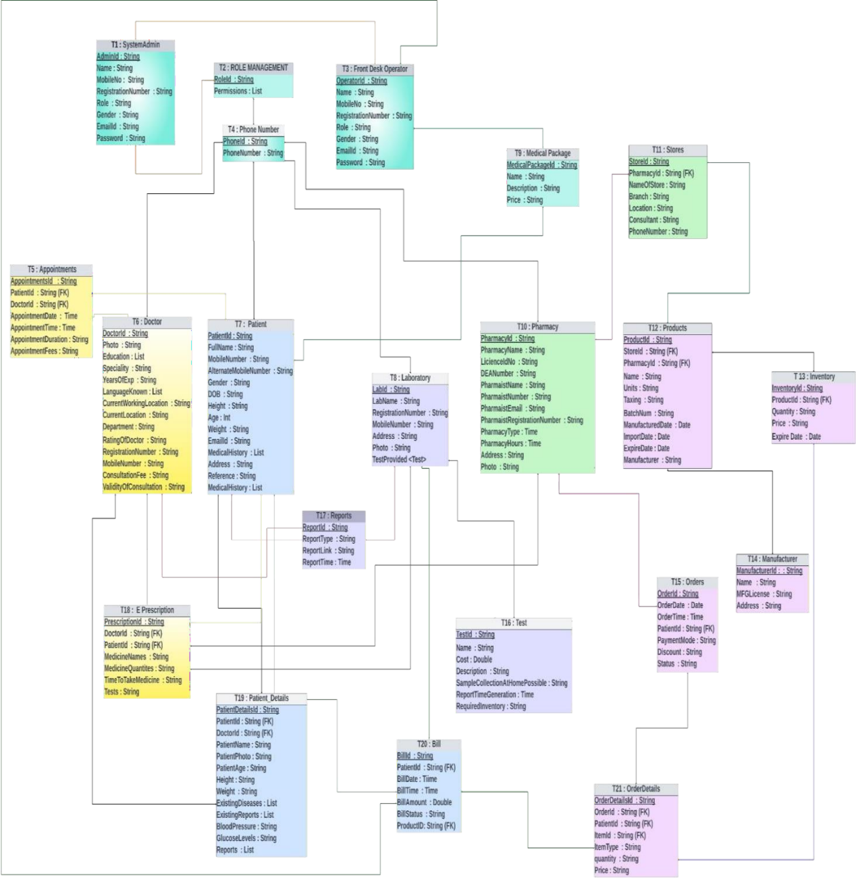

Figure 3.4 Data Base design

***3.4.1 : Database Design***

* T1 : SystemAdmin : AdminId (PK) ,Name , MobileNo , RegistrationNumber , Role , Gender , EmailId, Password : This is the super user in the proposed system. Admin will have access to all the Modules.
* T2 : ROLE MANAGEMENT : RoleId (PK), Permissions : This table is used for permissions.
* T3 : Front Desk Operator : OperatorId (PK), Name , MobileNo , RegistrationNumber , Role , Gender, EmailId , Password : Bills and payments can also be accessed by the Front desk operator. The front desk operator will have access to all and medical packages and discounts will be managed by front desk operator .
* T4 : Phone Number : PhoneId (PK), PhoneNumber : It will store all the phone numbers.and with accordinly give access to the particular user.
* T5 : Appointments : AppointmentsId (PK), PatientId (FK), DoctorId (FK) ,AppointmentDate, AppointmentTime , AppointmentDuration , AppointmentFees : The appointemnts booking will be stored in this table with reference to the patinetsid and doctorsID .
* T6 : Doctor : DoctorId (PK), Photo , Education ,Speciality , YearsOfExp ,LanguageKnown, CurrentWorkingLocation ,CurrentLocation , Department ,RatingOfDoctor RegistrationNumber , MobileNumber ,ConsultationFee ,ValidityOfConsultation : The individual doctor details will be stored here and Doctorid is the Foreign key. It has a relationship with E Precription table.
* T7 : Patient : PatientId , FullName , MobileNumber , AlternateMobileNumber , Gender , DOB , Height , Age : Int Weight , EmailId , MedicalHistory , Address , Reference , MedicalHistory .
* T8 : Laboratory : LabId , LabName , RegistrationNumber , MobileNumber , Address , Photo , TestProvided <TEST > : Apart from laboratory details, this table is connected to Test table.
* T9 : Medical Package : MedicalPackageId , Name , Description , Price : The medical packages which are dialy updated by the front desk operator will be stored in this and will be accessed by the patients and they can use the packages .
* T10 : Pharmacy : PharmacyId , PharmacyName , LicienceIdNo , DEANumber , PharmaistName PharmaistNumber , PharmaistEmail , PharmaistRegNumber , PharmacyType PharmacyHours ,Address , Photo : Maintains pharmacy operations. It has connections to the Store table.
* T11 : Stores : StoreId , PharmacyId , (FK) NameOfStore , Branch , Location , Consultant , PhoneNumber : The stores contains all the stores which are registred under the pharmacy table. The store table is connected to the products table.
* T12 : Products : ProductId , StoreId , (FK) PharmacyId , (FK) Name , Units , Taxing , BatchNum , ManufacturedDate , ImportDate , ExpireDate , Manufacturer : Contains all the Products like medicines etc., available in the stores. This table has relationship with inventory table.
* T13 : Inventory : InventoryId , ProductId , (FK) Quantity , Price , Expire Date : Comprises all medicines details. Like how many tables from a company and its details . This has relationship with ordered details table.
* T14 : Manufacturer : ManufacturerId : , Name , MFGLicense , Address : The manufacturer details of the medicines will be stored In this .
* T15 : Orders : OrderId , OrderDate , OrderTime ,PatientId , (FK) PaymentMode , Discount , Status , : Ther orders which are received from the patient will be stored in this .
* T16 : Test : TestId , Patient ID , (FK) Name , Cost : Double Description , SampleCollectionAtHomePossible , ReportTimeGeneration ,Required Inventory : The test table will contain all the tests provided by the laboratory.
* T17 : Reports : ReportId ,ReportType ,ReportLink,ReportTime : will be accessed by Doctors, lab operator, patient
* T18 : E Prescription : PrescriptionId (PK), DoctorId (FK) ,PatientId (FK), MedicineNames MedicineQuantites , TimeToTakeMedicine , Tests : Contains the prescription given by the doctors which will be accessible by the Patient, Pharmacy and Lab operator.
* T19 : Patient_Details : PatientDetailsId ,PatientId (FK), DoctorId (FK), PatientName , PatientPhoto , PatientAge , Height , Weight , ExistingDiseases, ExistingReports , BloodPressure, GlucoseLevels ,Reports : It has relationship with Doctor Table. By this the doctor can view the health conditions of the patients before consultation.
* T20 : Bill : BillId (PK), PatientId (FK), BillDate ,BillTime , BillAmount , BillStatus , ProductID, (FK) : Contains all the billing information. The bills belong to patient, pharmacy, laboratory and consultation Fees. It is connected to front desk operator table.
* T21 : OrderDetails : OrderDetailsId (PK), OrderId (FK) ,PatientId (FK), ItemId (FK) ,ItemType , quantity,Price : This contains all the orders received from the patient.
* Patient Module : Registration, Online consultation, Follow-up consultation, Schedule lab test, Previous consultations, Profile management
* Doctor Module : Registration, Today’s consultations, Previous consultations, Calendar, View Scheduled Appointments ,Receive Notifications, View lab reports, Prescribe lab tests, Prepare Prescription
* Pharmacy Module : Generate invoice, Payments, Stock availability etc.
* Lab operator Module : Today’s appointments, Previous appointments, Upload reports
* System Admin Module : Access to all the Modules
* Front desk Operator Module : Controlled by system admin and access accordingly, Managing other information like payments, medical packages, discounts.
  1. **WORK FLOW DESIGN**

The workflow diagram delineates a sophisticated healthcare information system designed to streamline patient engagement from initial contact through treatment and follow-up. The system architecture integrates multiple operational facets, including user registration, secure login mechanisms, and patient-doctor interaction. At the onset, new users are systematically onboarded and existing users re-enter through a secure two-factor authentication, ensuring data confidentiality. Upon successful entry, the system affords patients the autonomy to select healthcare providers based on symptoms or preferred consultation mode, whether audio, video, or text-based.

Subsequent to provider selection, the front desk operator facilitates the booking process, interfacing with a comprehensive database that holds patient history and doctor availability. This enables tailored scheduling that takes into account previous medical reports and doctor schedules, culminating in a confirmed consultation appointment. The subsequent workflow encompasses financial transactions where a patient's financial responsibility is communicated through an itemized bill. Secure payment gateways collect payment information and confirm transaction completion, linking directly to the system's billing operations.

Post-consultation, the workflow transitions into report management and prescription fulfillment. Clinical reports are uploaded, contributing to a dynamic patient profile within the database. This patient-centric dossier may trigger ancillary healthcare actions such as lab test bookings or medication orders. Lab operators interact with the system to provide test availability and manage inventory, while pharmacists engage with the pharmacy database to confirm drug availability and process orders, streamlining the prescription fulfillment process.

Interconnecting these components is a robust feedback mechanism, ensuring data integrity and real-time updates across the system. Each interaction—from booking to billing to prescription management—is meticulously logged, fostering a transparent and efficient healthcare delivery model. In essence, the diagram represents an integrated healthcare management ecosystem that is patient-centered, data-driven, and highly responsive to the multifaceted dimensions of patient care and administrative logistics. This system epitomizes the convergence of healthcare and information technology, striving for operational excellence while prioritizing patient welfare and data security.

The workflow diagram represents a robust healthcare management system that integrates multiple functions essential for modern healthcare delivery. It is patient-focused, data-centric, and likely utilizes advanced technology to ensure efficiency and compliance with health service standards. It encapsulates the complex nature of healthcare operations and the need for streamlined processes to enhance patient care and service delivery.

***3.5.1 User Creation and Login:***

New users are added to the system's database, while existing users can log in with two-factor authentication (2FA).

***3.5.1.1 Booking a Consultation:***

* Patients can select a doctor either by symptom description or mode of consultation (audio/video/text) using the front desk operator's database.
* The front desk operator accesses the doctor's availability and the patient's previous reports to help book a consultation.
* Once a consultation is booked, the schedule is confirmed with the doctor, and the consultation confirmation is sent to the patient.

***3.5.1.2 Payment Process:***

* After booking, the patient’s bill is generated.
* The patient then provides payment information and receives a payment confirmation once the billing is performed.

***3.5.1.3 Post-Consultation Process:***

* After the consultation, any reports generated are uploaded to the patient database.
* A patient summary is created which can lead to further actions such as booking lab tests or ordering medication.

***3.5.1.4 Lab Tests:***

* If a lab test is necessary, the lab operator checks for test availability in nearby laboratories using the laboratory datastore.
* The patient or front desk operator selects the required tests, and a booking for the lab test is made.
* Once tests are performed, the lab operator updates the database, which in turn reduces stock if any materials were used.

***3.5.1.5 Prescriptions and Pharmacy:***

* The patient or pharmacist can book medication, where the pharmacist checks the pharmacy database for availability.
* If the medication is available, an order is placed and then the stock is reduced accordingly.

***3.5.1.6 Additional Workflow Links:***

* Throughout the process, there are multiple feedback loops and data access points that ensure information is up-to-date and shared among relevant parties.
* For example:Payment information flows to and from the payment confirmation and billing processes. Patient reports and summaries can be used to update the patient database or schedule further consultations or tests.

***3.5.1.7 Ancillary Operations:***

The system also supports ancillary operations like confirming delivery of orders (medications, lab results), updating databases (laboratory, pharmacy, records), and managing inventory (reduce stock).

***3.5.2 User Registration and Authentication :***

***3.5.2.1 System Admin:***

Oversees user creation and maintains the system's integrity. They ensure new users are added correctly and existing users have a secure login mechanism.

***3.5.2.2 Records Database:***

Acts as a central repository for storing and retrieving patient records. This ensures historical patient data is accessible for medical consultations.

***3.5.3 Consultation Process***

***3.5.3.1 Front Desk Operator Database:***

This database contains information regarding the doctors schedules and specializations. The front desk operator uses this to facilitate the booking process.

***3.5.3.2 Selection of Doctors:***

Patients have the flexibility to choose a doctor based on symptoms or preferred mode of consultation. This patient-centric approach is critical for personalized care.

***3.5.4 Payment and Billing***

***3.5.4.1 Payment Information:***

The process involves secure handling of payment details, indicating a system that likely complies with standards such as PCI DSS for financial transactions.

***3.5.4.2 Billing:***

This step is crucial for the financial sustenance of the healthcare provider. It must be both efficient and transparent to maintain trust.

***3.5.5 Medical Reporting and Follow-up***

***3.5.5.1 Upload Reports:***

Post-consultation actions include uploading medical reports to the patient database, ensuring the continuity of care.

***3.5.5.2 Patient Summary:***

A comprehensive summary is essential for maintaining a complete health record, useful for future medical references or consultations.

***3.5.6 Laboratory Testing***

***3.5.6.1 Laboratory Datastore:***

This component holds information on available tests, which can be complex given the variety of medical tests available.

***3.5.6.2 Book Lab Test:***

Scheduling tests must be timely and accurate, reflecting the urgency and necessity of the tests prescribed by the healthcare provider.

***3.5.7 Medication Management***

***3.5.7.1 Pharmacy Database:***

Contains a list of medications, their availability, and possibly interactions, which is vital for dispensing the right medication.

***3.5.7.2 Place Order:***

Indicates a system linked with inventory management, ensuring medications are in stock when needed by patients.

***3.5.7.3 System Integration***

The workflow diagram shows how each component is interconnected. It's not just about individual tasks but also about how these tasks communicate with one another to form a cohesive system.

***3.5.7.4 User-Centric Approach***

Throughout the workflow, there is a clear emphasis on the patient's experience, with multiple touchpoints for patient engagement and feedback.

***3.5.7.5 Data Privacy and Security***

The system appears to have security measures in place, such as 2FA for user login, which is critical given the sensitive nature of healthcare data.

***3.5.7.6 Administrative and Operational Efficiency***

The diagram suggests a system designed for operational efficiency. For example, the reduction in stock is automated following lab tests, which implies a system that supports inventory management.

***3.5.7.7 Technological Infrastructure***

The workflow implies a sophisticated technological infrastructure that supports various functionalities such as video consultations, real-time updates to databases, and secure payment processing.

***3.5.7.8 Compliance and Standards***

The system would need to comply with various healthcare regulations, such as HIPAA in the United States, which governs the privacy and security of patient information.

***3.5.7.9 Scalability and Maintenance***

Given the complexity of the workflow, the system likely includes features for scalability to accommodate a growing number of users and maintenance routines to ensure the continuous, smooth operation of all components.

**WORK FLOW DESIGN :**

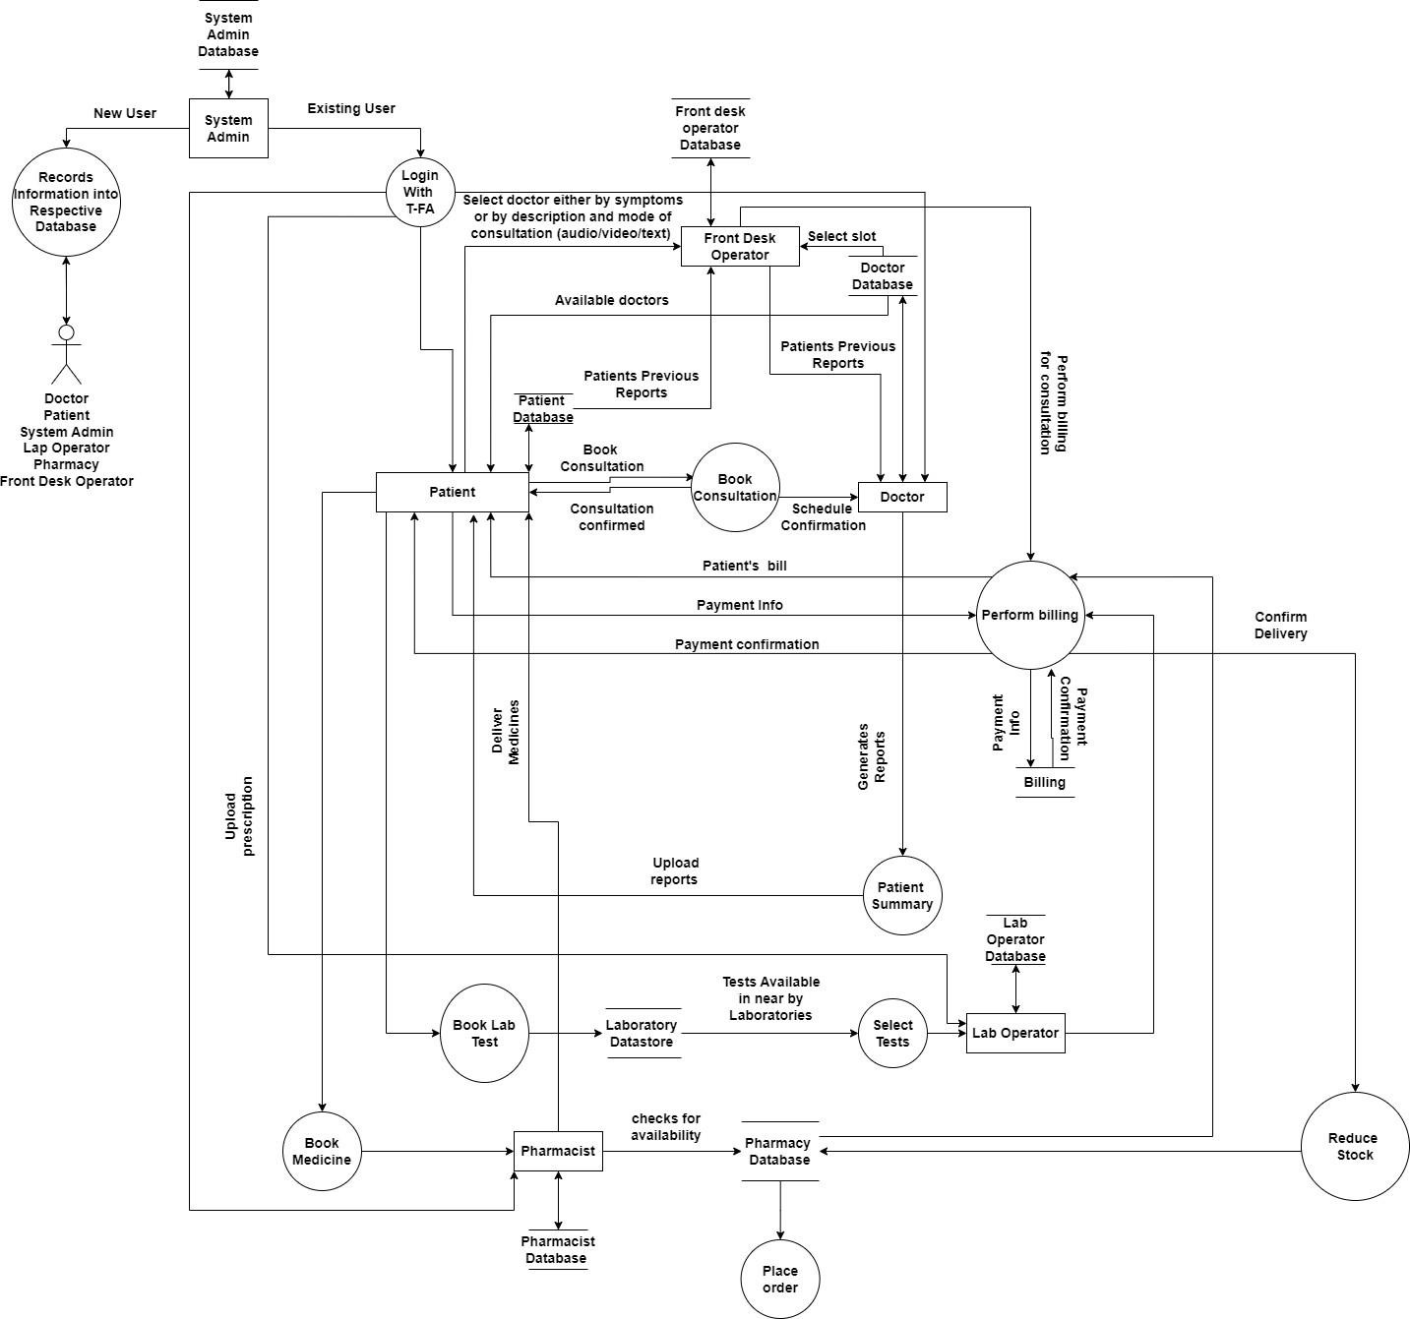

Figure 3.5 WORK FLOW DESIGN

***3.6 Implementation Steps:***

Step 1: Install Visual Studio Code

* Download and install Visual Studio Code from the official website.
* Open Visual Studio Code after installation.

Step 2: Install Node.js

* Download and install Node.js from the official website (https://nodejs.org/).
* Ensure that Node.js and npm (Node Package Manager) are installed correctly.

Step 3: Install Expo CLI

* Open your terminal or command prompt.
* Install Expo CLI globally by running: npm install -g expo-cli.

Step 4: Create a New React Native Project

* Create a new React Native project by running: expo init MyProjectName.
* Follow the prompts to choose a template and provide your project's name.

Step 5: Navigate to the Project Directory

Use the cd command to navigate to your project directory: cd MyProjectName.

Step 6: Start the Development Server

* Start the Expo development server by running: expo start.
* This will open a web page in your default browser with a QR code.

Step 7: Set Up Expo on Your Mobile Phone

* Install the Expo Go app on your mobile phone from the app store.
* Open the Expo Go app and scan the QR code displayed on the web page opened in the previous step.

Step 8: Implement the Mobile Application

* Open Visual Studio Code and open your React Native project folder.
* Begin implementing your mobile application using React Native, based on your UI designs.
* Save the code and check the Expo Go app on your mobile phone

**CHAPTER-4**

**Results and Observations**

**4.1 PATIENT MODULE :**

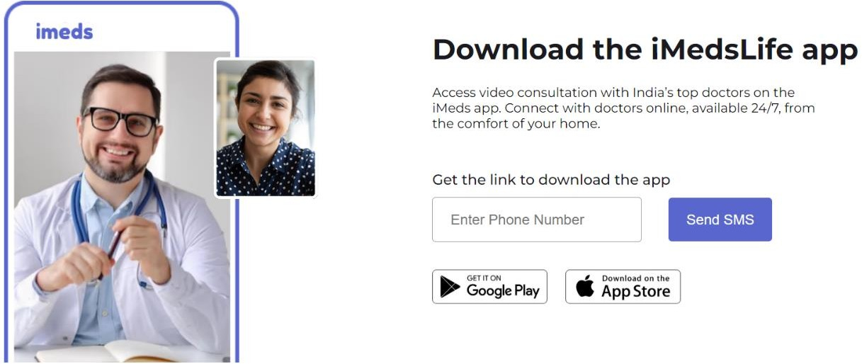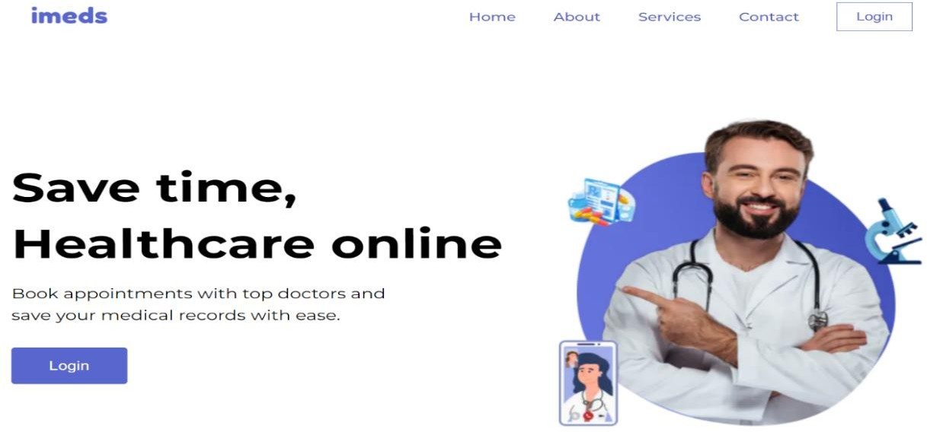

Figure 4.1.1 landing page of the patient module

The Patient Module in the healthcare information system is pivotal in enhancing patient engagement and streamlining care delivery, offering a user-friendly interface for easy navigation and interaction. It supports efficient new user registration with robust security through two-factor authentication and enables existing users to effortlessly manage their profiles and access medical records. This module simplifies the consultation process by allowing patients to book appointments based on specific symptoms or preferred consultation modes, and integrates a secure payment system that expedites the billing process. Real-time updates to medical records post-consultation and a feedback mechanism for continuous improvement are also notable features that have led to increased patient satisfaction and improved health outcomes, demonstrating the module’s effectiveness and operational excellence within the healthcare service delivery framework.

Figure 4.1.1 This landing page is effectively designed to communicate the key benefits of the service quickly and invite new users to sign up and existing users to log in, suggesting a seamless digital healthcare experience awaits behind the login.

Figure 4.1.2 LOGIN USING NUMBER

Fig 4.1.2 depicts that the Users are prompted to enter their mobile number to receive a One-Time Password (OTP) for verification. Upon entering their number and verifying the OTP, users will gain access to their account page. The process is user-friendly, prioritizing quick and secure access with minimal hassle. By using a mobile number and OTP, the system ensures a higher level of security compared to traditional password methods. This method also simplifies the process for users, as there are no passwords to remember. The login page is straightforward, with a clear call to action and a reference to the platform's Terms and Conditions, ensuring that users are aware of the agreement terms when creating an account or signing in.

After confirming the OTP, the user is logged into their dashboard ,Here, they can book an online consultation by clicking the 'Find Doctor' button and also view their consultation schedule. OR if the user is new he will be navigated into create account page.

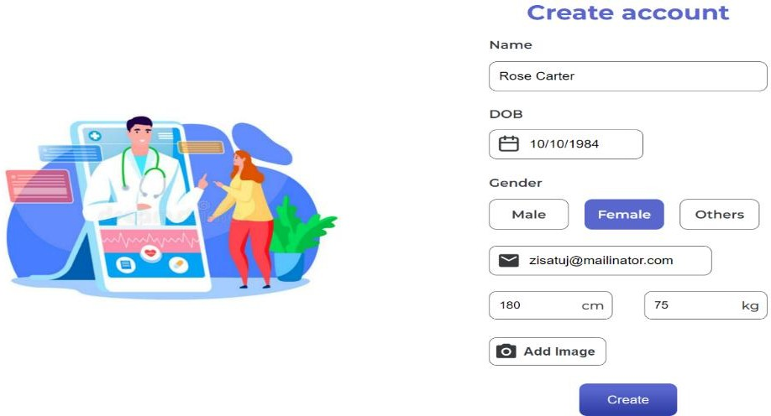

Figure 4.1.3 New user registration

Figure 4.1.4 Select the user

The fig 4.1.4 shows the user profile page on the "ishah" platform is intuitively designed to cater to individual and family health management. Once logged in, users are greeted by a personalized interface where their main profile is displayed. This is especially useful for users who intend to manage not only their health records but also those of their family members. The "Add Profile" button is a prominent feature on this page, allowing users to seamlessly add additional family members to their account. This functionality simplifies the process of tracking health consultations and records for each

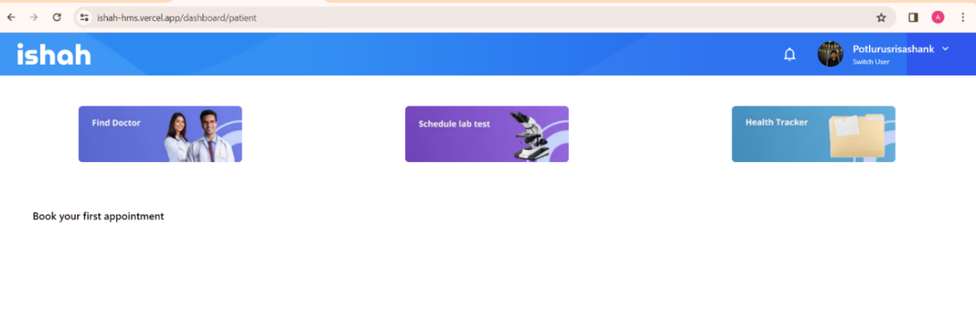

Figure 4.1.5 User profile page.

family member under a single user's account. It is user-centric in its approach, ensuring that accessing and managing multiple health profiles is both convenient and efficient. Overall, the design and functionality demonstrate the platform's commitment to providing a family-friendly health management solution.

The Fig 4.1.5 shows the user dashboard is a central hub designed for streamlined healthcare management. It presents users with three distinct options: 'Find Doctor', 'Schedule Lab Test', and 'Health Tracker'. The 'Find Doctor' feature empowers users to search for and book consultations with healthcare professionals, facilitating timely medical advice. The 'Schedule Lab Test' option provides a convenient pathway to arrange necessary medical tests, ensuring that health assessments are promptly conducted. The 'Health Tracker' is a pivotal tool for users to upload and maintain personal health records, creating a comprehensive digital health profile. Each option is symbolized by an intuitive icon, making navigation straightforward even for first-time users. This page is fundamental in supporting users to take proactive steps in managing their health, underlining the platform's commitment to providing accessible and organized healthcare services. The call to action, 'Book your first appointment', encourages users to take immediate steps towards their healthcare goals, demonstrating the platform's user-centric design.

Figure 4.1.6 symptom selection page

Fig 4.1.6 describes the patient to choose up to 3 symptoms for the page. The "ishah" platform's symptom checker page is an innovative feature that allows users to identify and select up to three symptoms from a comprehensive list. This interactive tool is backed by an intelligent algorithm which uses a dataset correlating symptoms with medical specialties. Each symptom is assigned a binary value in relation to different specialties—'1' for relevant and '0' for not relevant. Upon selecting their symptoms and clicking the 'Choose Doctor' button, the user’s choices are processed through the algorithm, which calculates a score for each specialty based on the symptoms provided. The specialties with the highest scores are deemed most relevant to the symptoms. The platform then retrieves and displays a list of available doctors with those specific specialties, facilitating a seamless connection between the patient’s needs and the appropriate medical expert. This data-driven approach enhances the user's experience by streamlining the process of finding the right doctor for their health concerns. This interactive tool is backed by an intelligent algorithm which uses a dataset correlating symptoms with medical specialties. Each symptom is assigned a binary value in relation to different specialties—'1' for relevant and '0' for not relevant. Upon selecting their symptoms and clicking the 'Choose Doctor' button, the user’s choices are processed through the algorithm

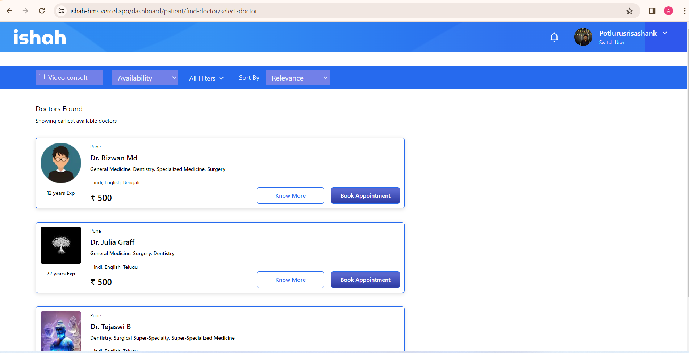

Figure 4.1.7 doctor selection page

This page lists available doctors shown in Fig 4.1.7, providing essential details for each medical professional:

Photo and Name: Each entry features a photograph and the full name of the doctor, personalizing the search results and helping users to identify their chosen practitioner.

Specializations: The doctors’ areas of expertise are listed, such as General Medicine, Dentistry, Surgery, and specialized fields. This allows patients to choose a doctor based on the relevance to their health concerns.

Experience: The number of years each doctor has been practicing is displayed, offering an indication of their level of expertise and experience.

Languages: The languages spoken by the doctors are listed, ensuring that patients can communicate effectively with their healthcare provider.

Consultation Fee: The fee for a consultation is clearly stated, allowing patients to make informed decisions based on their budget.

Action Buttons: Two prominent buttons – 'Know More' and 'Book Appointment' – are provided for each doctor. 'Know More' likely leads to a more detailed profile, while 'Book Appointment' initiates the booking process.

Filters: Options to filter the search results by availability, additional filters, and sorting by relevance are visible, suggesting customizable search parameters to refine the doctor selection.

Appointment Type: There’s a tab indicating 'Video consult', implying that the platform supports virtual consultations, adding convenience for the user.

Location: The city where the doctors practice is indicated, which is important for patients who might prefer or require in-person visits.

Navigation and User Profile: At the top right, the platform allows the user to switch accounts, indicating support for multiple profiles, such as family members.

Figure 4.1.8 appointment booking

The image 4.1.8 shows the appointment scheduling page from the "ishah" healthcare platform. This interface is specifically designed to offer patients a user-friendly means of booking appointments, which can be conducted via video or audio calls, as per the patient's preference. The system features a dual-option selection for the type of consultation, enabling patients to choose the most convenient communication method for their medical consultation. The page includes an interactive calendar that allows patients to select a date for the appointment, with options to quickly choose from 'Today', 'Tomorrow', or 'In 2 days'. Alongside the calendar, a range of time slots is presented, enabling patients to choose the exact time that suits their schedule. These time slots are dynamically updated to reflect real-time availability, ensuring patients have access to the latest scheduling options. Once a date and time have been selected, a 'Continue' button at the bottom of the page prompts the patient to finalize their appointment. This scheduling page epitomizes the integration of convenience and technology in modern healthcare, offering patients the flexibility to manage their healthcare appointments efficiently.

Figure 4.1.9 payment gateway page

Figure 4.1.10 payment processing page using razorpay

The image 4.1.10 shows the payment gateway interface provided by Razorpay, a popular payment solution. The interface is part of the "ishah" platform and is designed to facilitate financial transactions for services rendered. It presents the user with multiple options for payment:

UPI ID/Mobile Number Payment: Users can enter their UPI ID or mobile number associated with their UPI account to initiate the payment process.

UPI QR Code: There is a displayed QR code which users can scan with any UPI-compatible app on their smartphone to make the payment. This method is particularly convenient for quick and secure transactions.

Amount and Details: The specific amount to be paid, in this case, ₹500, is prominently displayed with an option to 'View Details' for a breakdown or further information about the payment.

Payment Validity: The interface indicates the validity of the QR code, suggesting a limited time frame within which the payment can be processed using the QR code.

Pay Now Button: A clear call-to-action, the 'Pay Now' button is designed to prompt the user to proceed with the payment.

Figure 4.1.11 Appointment conformation

In the Fig 4.1.11 Appointment details are clearly outlined, including the doctor's name, Dr. X, and their specialties, which include Dentistry, General Medicine, and Surgery. The consultation type is noted as a video call, suitable for remote medical advice and support, and the specific date and time of the appointment are provided. An additional convenience feature is the option for the user to request a reminder, which would be sent 10 minutes before the scheduled call, helping to ensure that the user is prepared and available at the time of the consultation.

In the fig 4.1.12 and 4.1.13 , where a user has options to reschedule or cancel an existing appointment with Dr. Rizwan Md, who specializes in General Medicine, Dentistry, and Specialized Medicine Surgery. The appointment, scheduled for a video consultation, is displayed with the doctor's profile image, name, specialties, and the precise date and time of the consultation. For users needing to cancel their appointment, the interface provides a straightforward process where they are asked to select a reason for cancellation from a list of options, including having consulted another doctor, no longer feeling the need to consult, unexpected work commitments, or other unspecified reasons. By including a section for specifying the reason for cancellation, the system can gather data to improve service and understand patient behavior. Once a reason is selected, a prominent 'Cancel Appointment' button is presented, allowing users to complete the cancellation process. This feature signifies the platform's commitment to accommodating the user's changing circumstances while also collecting feedback to enhance their services. The design of this interface underscores the emphasis on user control and flexibility in managing their healthcare appointments.

Figure 4.1.12 Cancel appointment functionality

Figure 4.1.13 Cancel appointment conformation.

**4.2 DOCTOR MODULE**

The Doctor Module within a healthcare management system is a comprehensive tool designed to empower medical professionals with a seamless workflow for patient care. This module typically includes functionalities like managing appointment schedules, accessing patient medical records, and facilitating virtual consultations. Doctors can easily view their daily, weekly, or monthly calendars, adjust availability, and confirm upcoming appointments. They have the ability to review patient histories, lab results, and document treatment plans, ensuring continuity of care. Furthermore, the module often incorporates secure messaging features, allowing for direct communication with patients or collaboration with other healthcare providers. Some systems also enable prescription management, where doctors can prescribe medication electronically, directly linking with pharmacies for efficient patient service. Analytics features can be part of the module as well, providing insights into patient demographics, common ailments, and other data-driven observations that aid in practice management and decision-making. Overall, the Doctor Module is a critical component that centralizes various aspects of medical practice, optimizing the efficiency and effectiveness of healthcare delivery.

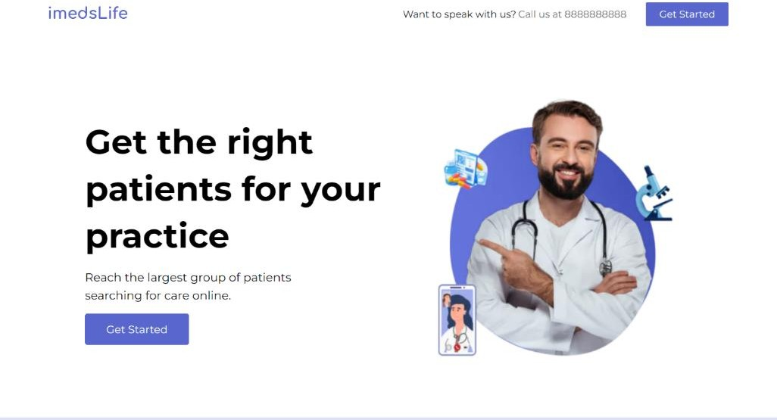

Figure 4.2.1 Doctor Module Landing page

In the Fig 4.2.1 describes the registration interface of the Doctor Module within the "ishah" healthcare platform, where medical practitioners can sign up to offer their services. The process is delineated into stages, as indicated by the numbered steps at the top of the form, suggesting a structured registration process. This particular step requires doctors to enter their personal and professional details, including first and last name, practice name, specialty, phone number, and email address. The statement "imedslife is the best way to reach the right patients for your practice. It's super easy to join" reassures doctors of the platform's efficacy and user-friendliness. A 'Sign Up' button at the bottom of the form initiates the submission process, which is followed by a commitment to notify the doctor within three days, and then provide the necessary credentials to access their new account. This setup aims to streamline the onboarding of healthcare providers, ultimately expanding the platform's network of professionals and enhancing the variety of accessible healthcare services for patients.

Figure 4.2.2 Doctor Registration Page

Figure 4.2.3 Registration of doctor

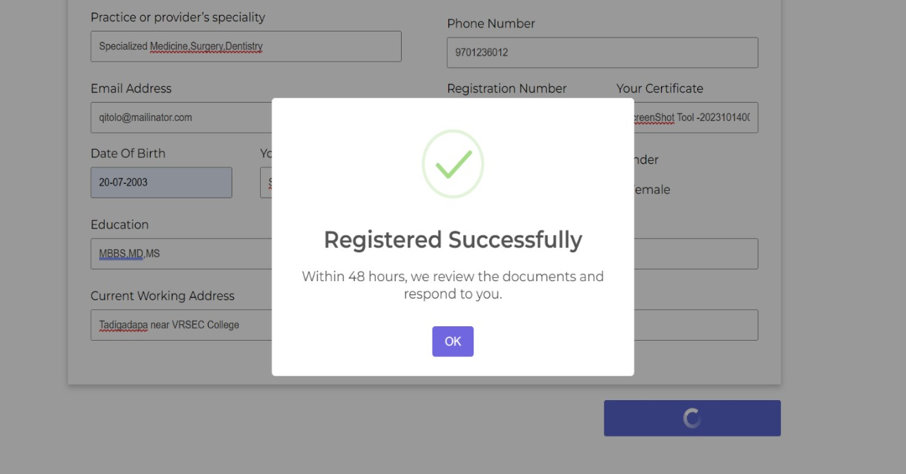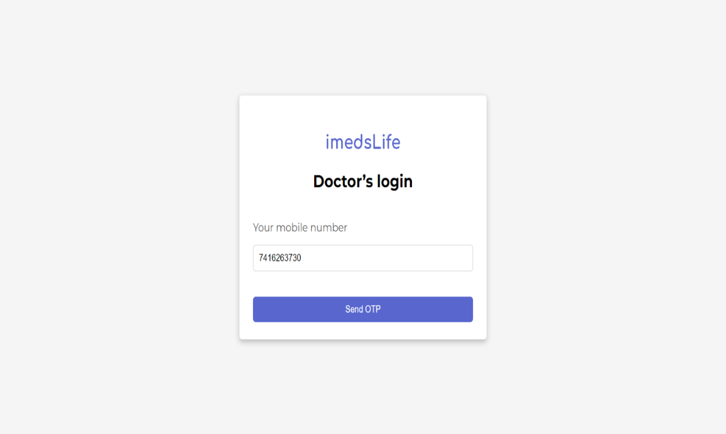

Figure 4.2.4 Doctor login

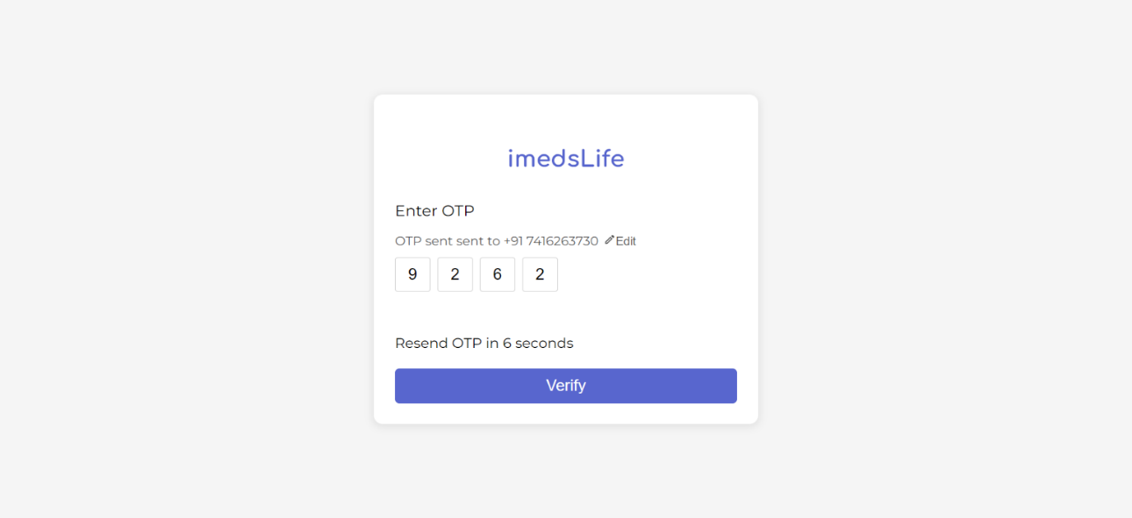

Figure 4.2.5 Doctor otp login via mobile

The image 4.2.5 displays an OTP (One-Time Password) verification screen for "imedslife," a secure step in the authentication process. The user is prompted to enter the OTP sent to their registered phone number, evidencing a focus on security and user verification. The design is minimalist, making the OTP input the central focus for a straightforward user experience. There's a reassurance that the OTP can be resent after a brief countdown, enhancing user convenience if the initial OTP is not received. The 'Verify' button is clearly visible, inviting users to complete the verification process after entering the received code. This system reflects a balance between user-friendly design and the stringent security measures necessary for protecting sensitive healthcare information.

Figure 4.2.6 Home Page of doctor dashboard

the homepage of the doctor's dashboard on the "ishah" healthcare platform. The welcoming interface greets Dr. Rizwan Md and offers an encouraging message to have a great day at work. It's a clear, well-organized layout that allows for easy navigation through various features such as appointments, patient management, schedule timings, payments, messaging, and more, all accessible via a vertical menu on the left side. A search bar is available at the top for quick access to patient records by ID or name. The main content area of the page shows "Today's Consultation" with an indicator that there are no appointments scheduled for the current day, represented by a calendar icon with a cross. The interface is designed for efficiency, aimed at simplifying daily tasks and streamlining the workflow for healthcare providers.

Figure 4.2.7 Home page displays the todays consultations

The fig 4.2.7 displays a detailed view of the "Today's Consultation" section on the home page of Dr. Rizwan Md's dashboard within the "ishah" healthcare platform. This personalized homepage informs Dr. Rizwan of his scheduled appointments. A particular appointment is shown with a patient, indicated by the name "Potlurissrishaank," who is a 21-year-old male presenting with symptoms of fever and gas. The appointment is scheduled for 17:00 on April 5, 2024, and a "Join Room" button is prominently displayed, suggesting that the doctor can enter a virtual consultation room to start the appointment. The design ensures that doctors have easy access to their daily schedule and can engage with their patients through the platform efficiently, offering a digital solution for managing consultations.

Figure 4.2.8 Appointment Section shows the missed and future appointments

The fig 4.2.8 to show a part of the doctor's appointment management interface within the "ishah" platform. This particular screen focuses on upcoming appointments, presenting a patient named Fazu, a 40-year-old female, who has an appointment due to fever. Her consultation is scheduled for 14:30 on April 2, 2024. A "Join Room" button suggests that this is a virtual consultation, and the doctor can initiate the session directly from the interface. The top tabs labeled "Future" and "Missed" imply that the doctor can view appointments that are upcoming as well as those that were not attended.

Figure 4.2.9 Video call consultation with Doctor

The FIG 4.2.9 showcases the virtual consultation interface within the "ishah" healthcare platform, representing a digital space where doctors and patients can engage in video consultations. This particular setup depicts an ongoing session between a user named potlurissrishaank and Dr. Rizwan Md, scheduled for April 5, 2024. The layout features the patient's video feed, with options for both the doctor and patient to manage their audio and video settings, share screens, and access further options via the "More" button. Notably, a chat function is available for text-based communication, enhancing the consultation's interactive capability. Designed for a 10-minute dialogue, this secure and private environment allows the doctor to provide medical advice, discuss symptoms, and deliver a prescription directly to the patient. The prescribed treatment will then be automatically saved in the patient's record for easy access and reference. This system streamlines the telemedicine experience, providing a comprehensive solution for healthcare consultations in a modern, digital format.

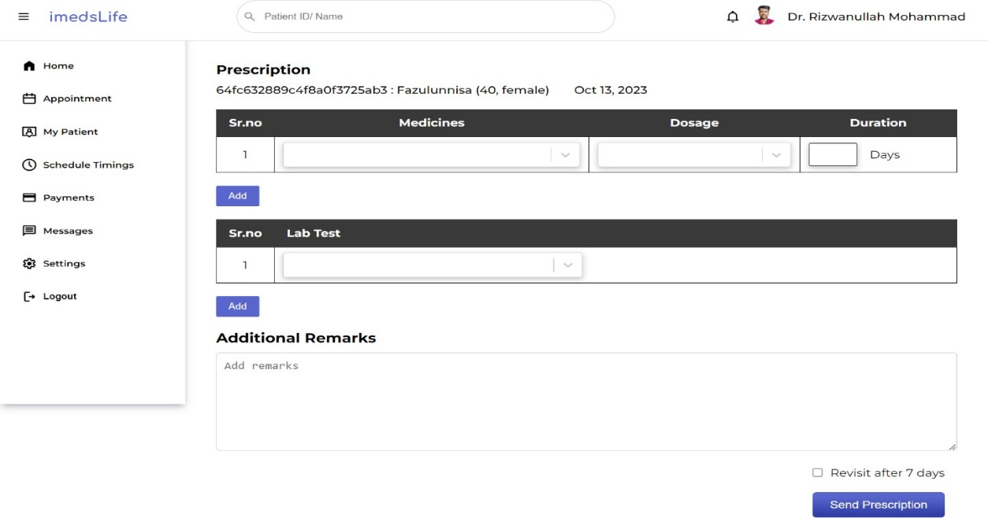

Figure 4.2.10 prescription page

The Fig 4.2.10 shows the prescription module of the "imedsLife" healthcare platform, used by doctors to issue medical prescriptions and recommend lab tests for patients. In this instance, Dr. Rizwanullah Mohammad is crafting a prescription for a patient named Fazulunnisa, a 40-year-old female, dated October 13, 2023. The interface allows for a meticulous entry of medication details, including the serial number, medicine name, dosage, and duration, ensuring a clear and structured medication regimen. There is also provision for ordering lab tests, where specific tests can be added as necessary. An additional remarks section is included, giving the doctor space to provide supplementary advice or instructions pertinent to the patient’s care. The checkbox at the bottom, "Revisit after 7 days," implies the platform’s capability to remind both the doctor and the patient of follow-up consultations. A "Send Prescription" button at the bottom finalizes the process, presumably updating the patient's records and notifying them of the new prescription. This module reflects the platform's comprehensive approach to bridging the digital gap between healthcare providers and the needs of

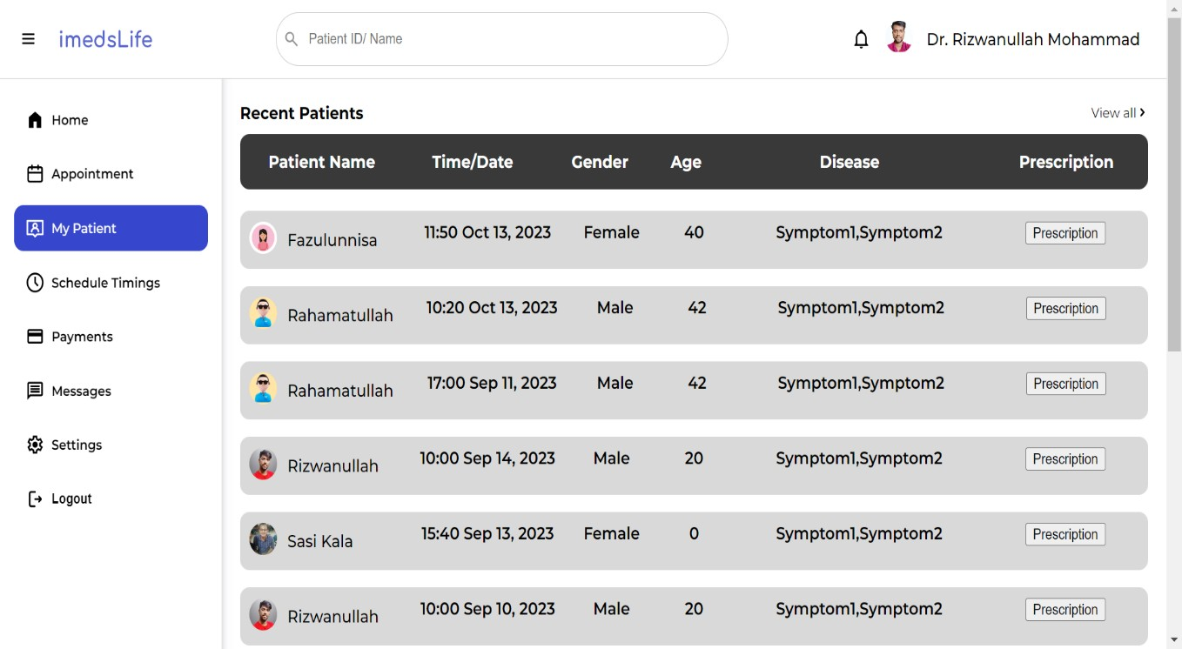

Figure 4.2.11 shows all the patients of the doctor

their patients.

The fig 4.2.11 shows the details of the "My Patient" section of the "imedsLife" healthcare platform, used by Dr. Rizwanullah Mohammad to track recent patient engagements. The interface neatly lists patients along with their appointment times, genders, ages, and a brief indication of their health concerns or symptoms. For each entry, there is an option to view the prescription, likely leading to more detailed information or the ability to edit the current medication plan.

The list shows appointments spanning different dates, with patients of varied ages, suggesting the platform's wide usage for managing diverse medical cases. The layout is designed for ease of access, allowing the doctor to quickly navigate through the recent patient history and efficiently manage follow-up actions. This tool enhances the doctor's ability to monitor ongoing treatments, ensuring a smooth continuum of care for their patients. The consistent format of the list, coupled with the immediate link to prescriptions, reflects the platform's commitment to streamlining the healthcare management process.

**CHAPTER-5**

**Conclusion and Future Study**

* 1. **CONCLUSION:**

In conclusion, the development of an online consultation website is a valuable and effective solution for providing convenient and accessible healthcare services. This website offers numerous benefits for both healthcare professionals and patients as well and the online consultation website prioritizes privacy and security. By implementing robust data encryption and secure server systems, it ensures the confidentiality of patient information and medical records. Patients can confidently share sensitive details with healthcare providers, fostering trust and confidentiality.

Lastly, the online consultation platform promotes efficiency and productivity. Healthcare professionals can manage their schedules more effectively, reducing waiting times and optimizing their workflow. Patients experience reduced waiting times and enjoy the convenience of accessing healthcare services from the comfort of their homes.

**FUTURE STUDY:**

**Phase-1:**

Developing the Web Application for the Health Care Management System.

**Phase-2:**

Developing Mobile Application for the Health Care Management System.

**Phase-3:**

Apply Authentication & Security in Web application and Mobile application. Identify and handle OWASP API Security the Top 10 Vulnerabilities 2019 in APIs exposed by the web application.

Implement TLS v1.2 in APIs for securing data transfer between web server and mobile/web application. Implementation of logging and registration for all users in the proposed system. Design registrations, schedules, calendars, e-prescription through dashboard.

**References**

[1] International Journal of Healthcare management, Volume 14, Issue 4 (2021). Research on health administration, healthcare system, e-Health, patient satisfaction, healthcare marketing, medical tourism, health policy and reform.

[2] Hospital management system using web technology ISSN 0193 4120, May 2020: Kotapati Saimanoj, Grandhi Poojitha, Khushbu Devendra Dixit, Laxmi Jayannavar.

[3] Hospital Management and Control System ISSN 25158260, Volume 7, June 2020 (European Journal of Molecular & Clinical Medicine): Ashmita Gupta, Ashutosh Niranajan, School of Medical Sciences & Research, Uttar Pradedesh.

[4] HAMS: An Integrated Hospital Management System to Improve Information Exchange, CISIS- June, 2020: Francesco Lubrano, Federico Stirano, Gluseppe Varavallo, Fabrizio Bertone, Olivier Terzo.

[5] Hospital management System (International Research Journal of Engineering & Technology)- Volume: 07 Issue: 04 | April 2020: Pranjali Anpan, Roshni Udasi, Susneha Jagtap, Shon Thakre, Chalika Kamble.

[6] Review on the Smart Hospital Management System Technologies: RST Journal, Spring 2019: Najeh Lakhoua.

[7] Hospital Management System – International Journal for Research in Engineering Application & Management: M. Sowmya, D. AnilChandraVarma, M.Sailaja, M. Venugopalarao, T. Prasanth.